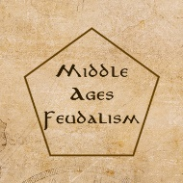Middle Ages Feudalism

Designer: Chaocheng Lin

* OVERVIEW
  1. Henry I, King of England, died on 1 December 1135 after a week of illness. Despite his plans for Matilda, the King was succeeded by his nephew, Stephen of Blois, resulting in a period of civil war known as the Anarchy. The Anarchy was a civil war in England and Normandy between 1135 and 1153, which resulted in a widespread breakdown in law and order. The conflict was a succession crisis precipitated by the accidental death by drowning of William Adelin, the only legitimate son of Henry I, in the sinking of the White Ship in 1120. Henry's attempts to install his daughter, the Empress Matilda, as his successor were unsuccessful and on Henry's death in 1135, his nephew Stephen of Blois seized the throne with the help of Stephen's brother, Henry of Blois, the Bishop of Winchester. Stephen's early reign was marked by fierce fighting with English barons, rebellious Welsh leaders and Scottish invaders. Following a major rebellion in the south-west of England, Matilda invaded in 1139 with the help of her half-brother Robert of Gloucester.
  2. Players are the lords of England and the heirs to the throne and will try to win the kingdom.
* GOAL
  1. Get the highest points in the game.
* NUMBER OF PLAYER: 2-4
* CONTENTS:
  1. 4-Sided Dice x 2
  2. Metal Dice (Red, Blue, Green, Yellow) x 4
  3. Plastic Dice x 4
  4. Main Board (350*350mm) x 1
  5. Player Screen x 12
  6. Serfdom Token x 72
  7. Monk Token x 72
  8. Knight Token (Red, Blue, Green, Yellow) x 72
  9. Archer Token (Red, Blue, Green, Yellow) x 72
  10. Plastic Pawn (Red, Blue, Green, Yellow) x 12
  11. Rectangle Game Tiles (3*6") x 4
  12. Plastic Gold Nuggets x 1LB
  13. Neon Colored Canvas Pouch Bags Sacks with Drawstring Closure x 12
  14. Dry Erase Markers x 4
  15. 1 Minute Sand Timer x 1
  16. Velvet Storage Bag x 1
  17. Pawns x 4
  18. 9x12 Battle Game Board x 3
  19. Cards (Castle, Gold mine, Farm, Monastery) x 24
* PRE- GAME SETUP
  1. Each player has 1 serfdom, 3 food, and 10 golds, and choose one color (Red, Blue, Green, Yellow).
  2. See who goes first. The player who is the eldest. Players take turns clockwise following the first player in the first round.
  3. Each player uses Player Screen to hide their Rectangle Game Tiles, resources, and three Plastic Pawns.

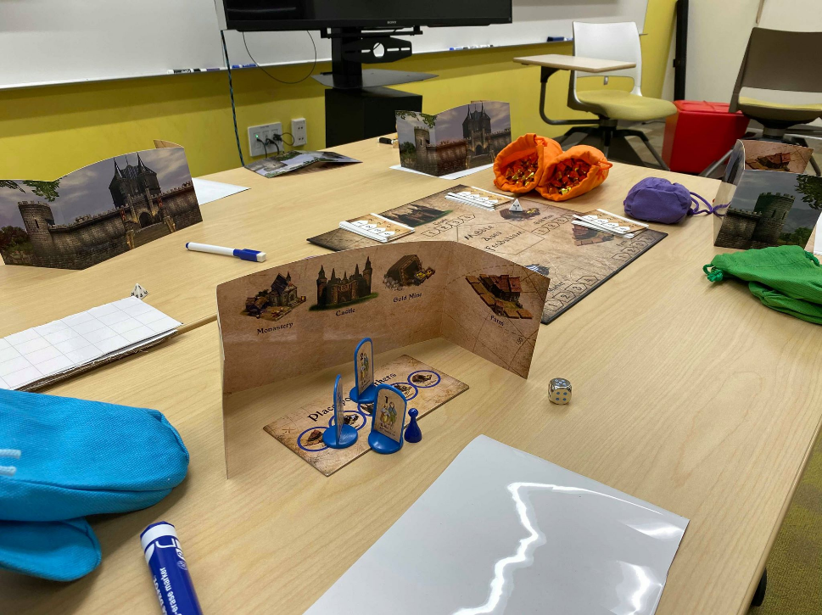

* 1. Place Cards near the Castle, Gold mine, Farm, Monastery.
* GAME-PLAY
  1. Produce food.: 3 food per 1 serfdom. Each player gain food from the king according to their serfdoms.
  2. Player will place their Plastic Pawns to their Rectangle Game Tiles (the number of plastic pawns means priority and order) in 1 minute.
  3. Then, the first player places his/her No.1 pawn to the main board. Next player places his/her No1 pawn to the main board (if someone has already on the first place, place on the second place), and so on.
  4. Turn the cards over and check how many stuffs every place can produce this round.
     1. Castle (Recruit army)- each army per 3 golds. The player will draw an army token and pay 3 golds per army.
     2. Gold Mine- roll the 4-sided Dice. The die’s number is the golds you can take.
     3. Farm (buy serfdom)- each serfdom per 2 golds.
     4. Market – trade with the king (3 food-> 1 gold or 3 golds-> 1 food) or trade to the other lords (negotiation by yourself)
     5. Monastery (monk training)- each monk per 2 golds.
  5. War (after fifth round)- see “Special – War”
  6. Food consumption- pay food for your residents of your manor
     1. 1 food per Serfdom, Monk
     2. 2 food per Knight, Archer
     3. If your food is not enough to eat, your residents will starve to death.
  7. Next round, the first player is the lord who has the most monks.
     1. If two or more lords has the same monks, the lords who has the most residents will have the higher priority.

Place order pawns to main board

Set the order to Game Tile

Produce food

Turn cards over and gain resources

War (after fifth round)

War (after fifth round)

* Special – War
  1. After fifth round, any lords can declare a war on the other lord.
  2. one war per round.
  3. When someone declares the war, the other lords need to choose to support the War initiator or her/his target (Can be neutral) in 30 second.
  4. The War initiator and his/her target (and their allied forces) need to choose the numbers of Army in 1 minute.
  5. Write on the War tactic board (9x12 Battle Game Board) by markers. (Only can setup your army on neutral and your battle field.)
  6. Place your Base (3 Hp) and army on the battle field (9x12 Battle Game Board).
  7. Then, the war initiator starts to move their army (Turn-based). [Move 1 grid.]
  8. Fight- The army who has less attack point will be killed.
     1. Knight-
        + Attack point: 6-Sided Dice+ number on the token.
        + Attack ranger:1 grid.
     2. Archer-
        + attack point: 4-Sided Dice+ number on the token.
        + Attack ranger:2 grids.
     3. Monk- Add 3 Attack point per fight.
  9. When one lord’s Base is destroyed, the lord loses the war.
  10. The winner can choose (food or golds), and the loser (and the allied forces) need to pay half of (food or golds) to the winner.
  11. The winner can distribute loot to the allied forces.
  12. See: <https://youtu.be/-ro_pqInM7k>
* End of the game
  1. After 10 rounds, every resource will become points.
  2. The lord who has highest point will be the new king.
  3. Point Transfer Rule

|  |  |  |
| --- | --- | --- |
| 1/3 point per Food | 1 point per Gold | 2 points per Serfdom |
| 2 points per Monk | 0 point per Knight | 0 point per Archer |